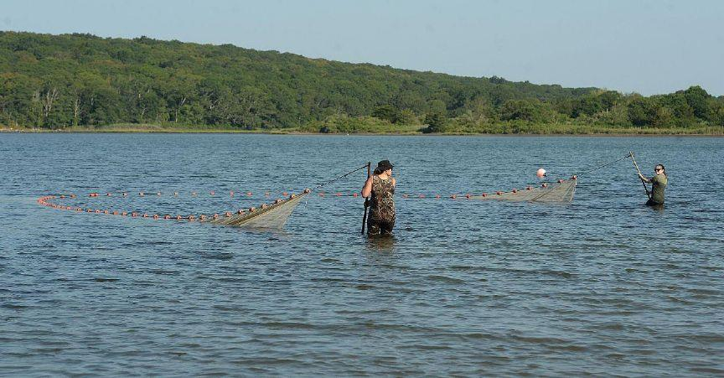
UConn Avery Point grad student Vicki You, left, and Kaitlyn Tripp, an under graduate research assistant, use a seine net to catch flounder species while at Mumford Cove in Groton Friday, Aug. 15, 2025. (Dana Jensen/The Day)
Is food competition one of the reasons for the decline of flounder in LI Sound?
3

By Kimberly Drelich
Day Staff Writer
The Day

Published:Sep 01, 2025 3:00 PMUpdated:Sep 01, 2025 2:50 PM
Groton — University of Connecticut doctorate student Vicki You and undergraduate research assistant Kaitlyn Tripp hauled in a 100-foot-long net from the waters of Mumford Cove on a recent sunny summer morning.
Once on the sandy shore, they and other UConn-Avery Point students pored over the net and counted the number and types of fish brought in during low tide. They counted 88 winter flounder, two summer flounder, and two black sea bass among 16 different fish species in the first haul of the day.
It's all part of an effort to monitor the fish diversity and ecological health of the cove and study the flounder population in Long Island Sound. Called "Bottoming Out? Testing Hypothesis on Why Long Island Sound Flatfishes Are Disappearing,” the project is being done by UConn researchers.
The principal investigator, Eric T. Schultz, emeritus professor in the Department of Ecology and Evolutionary Biology, said the project represents the first attempt to develop a picture of the food web of Long Island Sound as it relates to finfish.
The project is testing the hypothesis of whether black sea bass, scup, or porgy, and smooth dogfish, whose populations are surging in Long Island Sound, are competing with the flatfish and depleting their food — and whether this is a factor for the flounder's decreasing abundance.
Schultz said the winter flounder has not been doing well in Long Island Sound and in the region. Some other flatfishes, including the windowpane flounder, the fourspot flounder, smallmouth flounder, and summer flounder, also have been signaling potential trouble in their populations.
The winter flounder population had declined decades ago, with overfishing as well as potentially some stumbles in fisheries management being the likely cause, Schultz explained. The study will look at whether the lack of food is a problem impeding their recovery, with warming temperatures likely part of the story as well.
From 1984 to the early 1990s, the state Department of Energy and Environmental Protection's springtime Long Island Sound Trawl Survey (LISTS) would typically average more than 100 winter flounder in their net tows, but since 2002 the average catch has been below 50 fish per tow and dropped in the last decade to one to three fish, Schultz said.
Schultz said windowpane flounder similarly bottomed out. From 1984 to 1990, the spring trawl survey catch averaged more than 50 fish per tow, but since 2000 the catch has never reached more than 16 fish, and in the last decade has always been below five.
The fourspot flounder also was also more abundant before 2000, he said. The trawl survey catch exceeded five fish per tow in most years then, but since 2000 has reached that number only once, and in the last decade it has dipped to a few fish and even lower.
A trawl survey conducted by the Millstone Environmental Lab shows that the smallmouth flounder gradually rose in abundance from 1976 to 2014 and then sharply decreased to less than a fifth of what it was in its peak, Schultz explained.
Summer flounder, also known as fluke, rose in abundance in the 1980s and 1990s, peaking in 2002 at six fish per tow, according to the fall LISTS records. Since then, they have leveled off at about two to three fish per tow.
Schultz said that not as many young summer flounder are progressing to enter the adult fish population.
Schultz said the black sea bass, the scup, or porgy, and the dogfish are likely surging in population primarily due to warming waters. At the same time as they are surging, several species of crabs — which those fish may be feeding on — have seemingly been greatly depleted.
Schultz said that through several innovative techniques, researchers will seek to identify the degree of dietary overlap between the abundant species and the flatfish species showing signs of concern.
The project is funded through a $283,128 grant, awarded in December 2024 in a partnership between Connecticut and New York Sea Grant and the U.S. Environmental Protection Agency’s Long Island Sound Study, as well as matching funds.
Collecting fish
On the morning of Aug. 15, the research students were collecting the fish species that were part of the study for two approaches to identify their diet: dissecting the fish and freezing them and taking their gut contents to do a DNA analysis of what species are in their stomachs.
You wrapped the fish being sampled in foil and put them in a liquid nitrogen tank to later place in a negative 80-degree Celsius freezer back in the lab.
Hannah Roby, a PhD student at UConn-Avery Point, explained that flash freezing them in liquid nitrogen stops the digestion process. The goal is to study their diet and ecological interactions to see if the black sea bass, scup, or porgy, and dusky smooth-hound are eating the prey of the flatfish.
You said this is an important step toward conservation of the flatfish.
The fish species not being studied in the flounder research project were counted for baseline data that researchers could later use and the fish were released back into the water.
The researchers looked for clues to identify each type of fish, for example the winter flounder's eye points to the right, while the summer flounder has teeth and its eye points to the left.
UConn researchers are collecting juvenile fish this summer and next summer will focus on collecting larger fish. The state Department of Energy and Environmental Protection also is helping to collect fish along the coast.
The students are analyzing the fish stomach contents under the guidance of professor Hannes Baumann and Paola Batta-Lona, a research assistant professor, in UConn's Department of Marine Sciences. Schultz's assistant Katherine Helmer is retrieving tissues, particularly eye lenses, from the fish collected.
All the data will help provide an accurate picture of the fish diet, Schultz explained.
Helmer is also working with Max Zavell, a former doctoral student in UConn Marine Sciences and now a post doctoral associate in the University of Massachusetts, to help determine whether flatfish growth rates have changed over time. Sebastian Klarian, an associate professor at Andres Bello University in Chile, is doing statistical analysis for the project.
The project has significance as the flounder, particularly summer and winter flounder, are a target of anglers and are good food, and also holds clues for how this area of Long Island Sound is functioning, Schultz said.
What's happening in Connecticut's coastal ecosystems
Emma Siegfried, a PhD student at UConn-Avery Point, said Mumford Cove was a sewage dumping ground decades ago, but the sewage line has been re-rerouted. Baumann's lab at UConn has been monitoring the fish diversity there for years and how the ecosystem is rebounding.
She said Mumford Cove also is considered a nursery habitat for fish so it can provide a clue as to how fish populations are doing. For example, many juvenile fish in the water show the species' population likely is faring well, but the absence of a specific species could be an indicator of what is to come for the larger population.
Siegfried said understanding what's happening in Connecticut's coastal ecosystems is important, as the state is heavily centered on its coastline, with many people living along the coast or working jobs that rely on the coastline.
k.drelich@theday.com

